A000-AM,C-Taino-Anthropomorphic Head-Cemi-Andesite-1000 CE



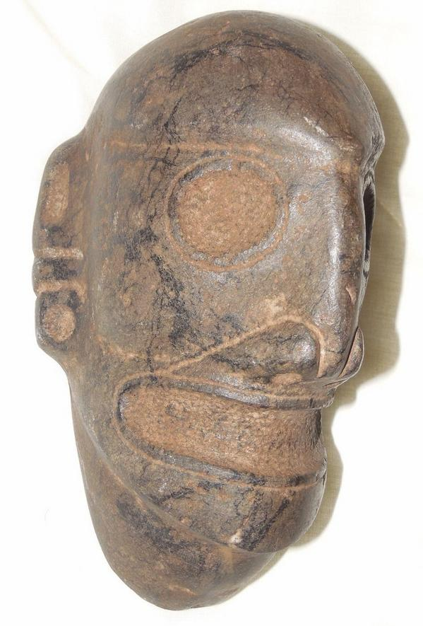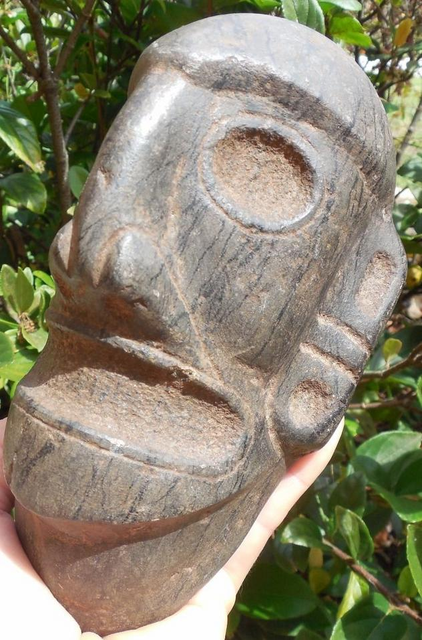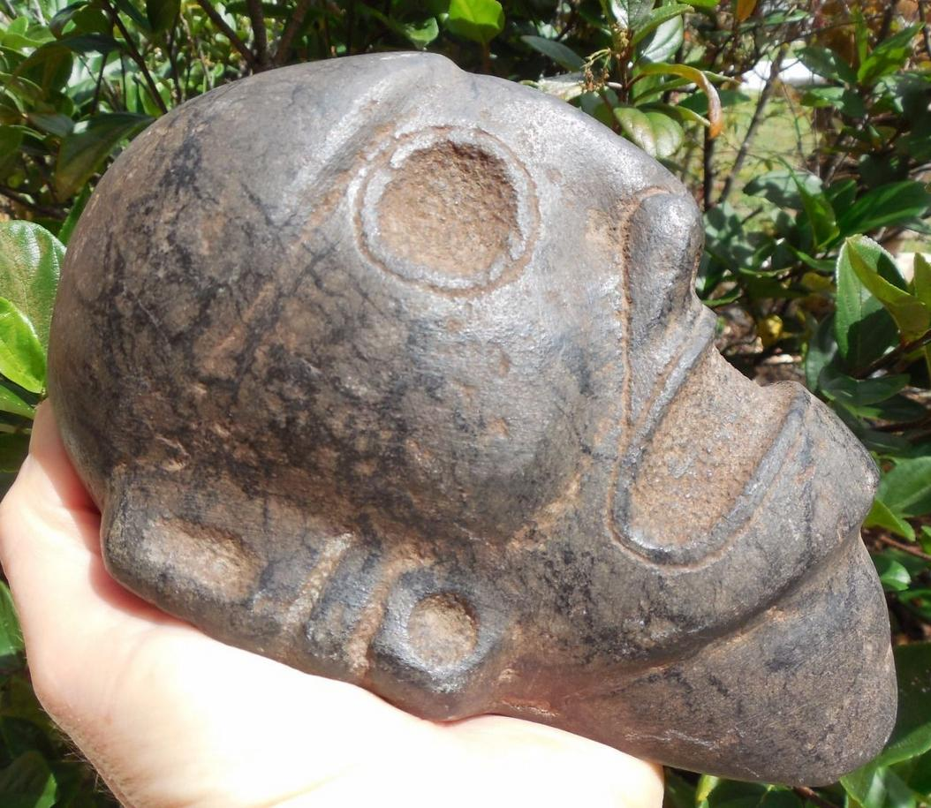

AM,C-Taino-Anthropomorphic Head-Cemi-Andesite-1000 CE

**Case No.: 17**

**Accession No.**

**Formal Label:** AM,C-Taino-Anthropomorphic Head-Cemi-Andesite-1000 CE

**Display Description:**

**LC Classification:**

**Date or Time Horizon:**

**Geographical Area:**

**Map:**

**GPS coordinates:**

**Cultural Affiliation:**

**Media:**

**Dimensions:**

**Weight:**

**Condition:**

**Provenance:**

**Discussion:**

**References:**